**Title: Setting Up JUnit for Unit Testing in a Maven-based Java Project (Using IntelliJ IDEA)**

**Objective:**

To configure the JUnit 4.13.2 testing framework in a Maven Java project and create a sample test case to verify setup success.

**Tools & Technologies Used:**

* **IDE**: IntelliJ IDEA (Community or Ultimate Edition)
* **Build Tool**: Apache Maven
* **Unit Testing Framework**: JUnit 4.13.2
* **Java Version**: JDK 1.8 or higher

**Steps Performed:**

**Step 1: Created a New Maven Project in IntelliJ**

* Group ID: com.ayush.testing
* Artifact ID: junit-demo
* No archetype was used (blank Maven project).

**Step 2: Added JUnit Dependency in pom.xml**

<dependencies>

<dependency>

<groupId>junit</groupId>

<artifactId>junit</artifactId>

<version>4.13.2</version>

<scope>test</scope>

</dependency>

</dependencies>

* IntelliJ auto-downloaded dependencies and indexed the project.

**Step 3: Created a Simple Class to Test**

//Calculator.java

package com.ayush.testing;

public class Calculator {

public int add(int a, int b) {

return a + b;

}

}

**Step 4: Created a Test Class**

//CalculatorTest.java

import com.ayush.testing.Calculator;

import org.junit.Test;

import static org.junit.Assert.assertEquals;

public class CalculatorTest {

@Test

public void testAdd() {

Calculator calc = new Calculator();

int result = calc.add(5, 3);

assertEquals(8, result);

}

}

**Step 5: Executed the Test**

* Right-clicked on the test file → **Run 'CalculatorTest'**
* Result: **Test Passed Successfully**
* Output: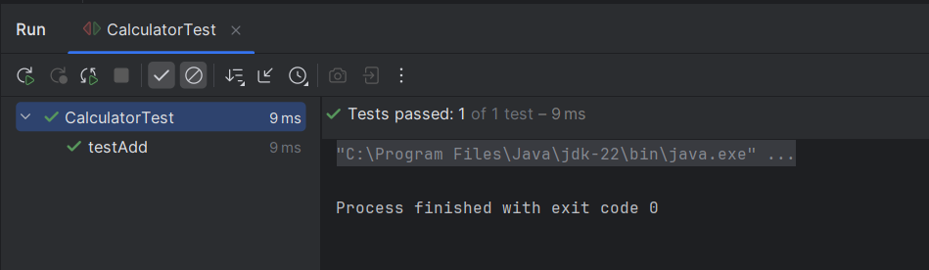

**Conclusion:**

* Successfully set up **JUnit 4.13.2** with **Maven** in IntelliJ.
* Created and executed a basic unit test.
* Environment is now ready for writing more advanced unit test cases in future exercises.